

**SANYO 2.3 Ton RQ71CXV1**

**Rs. 299,000/-**

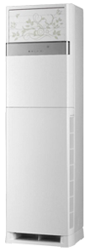

**Product Features**

* State of the Art
* Air Vane Technology
* Auto Swing
* power mode
* precise system control technology

**Specification**

**Type** Wall Mounted Split AC

**Cooling (Btu/h)** 42000

**Voltage (V)** 220-240

**Power Input (W)** 4100

**EER (Btu/W-h-W/W)** 5.7-1.8